

Contents

Introduction 3

Understandings made with group members and the teacher/client 3

Task Delegation 5

Explanation of choices as solutions to problems encountered 6

Personal Evaluations 7

# Introduction

As part of the requirements of ProCP, which is the final project of the core phase. We as a group (4 Cube) consisting of Coen Stange, Wen Li, Yongshi Liang and Agnes Wadee, had a project to make a Traffic Simulation Application. Not only did we have to do the software development aspect of the project, but also make documentations such as a User Requirements Specification (URS) Document, Design Document and finally a Process Report. This document being the process report, will elaborate on success and challenges faced during our participation in this project.

This document will give a brief overview of decisions made concerning the project with ourselves as a group and also our formal client/lecturer. We will also outline the division of task among ourselves in parallel with the time spent on the tasks. The document will also give an overview of choices we made and also problems we encountered and how we were able to solve them.

# Understandings made with group members and the teacher/client

The project was scheduled into two blocks, the first block was for documentation and the second was for implementation.  
During the first block of the project, we had a meeting once a week with the teacher. Below are the minutes recorded from the meeting which elaborates the feedback from the teacher and some decisions we made a group.

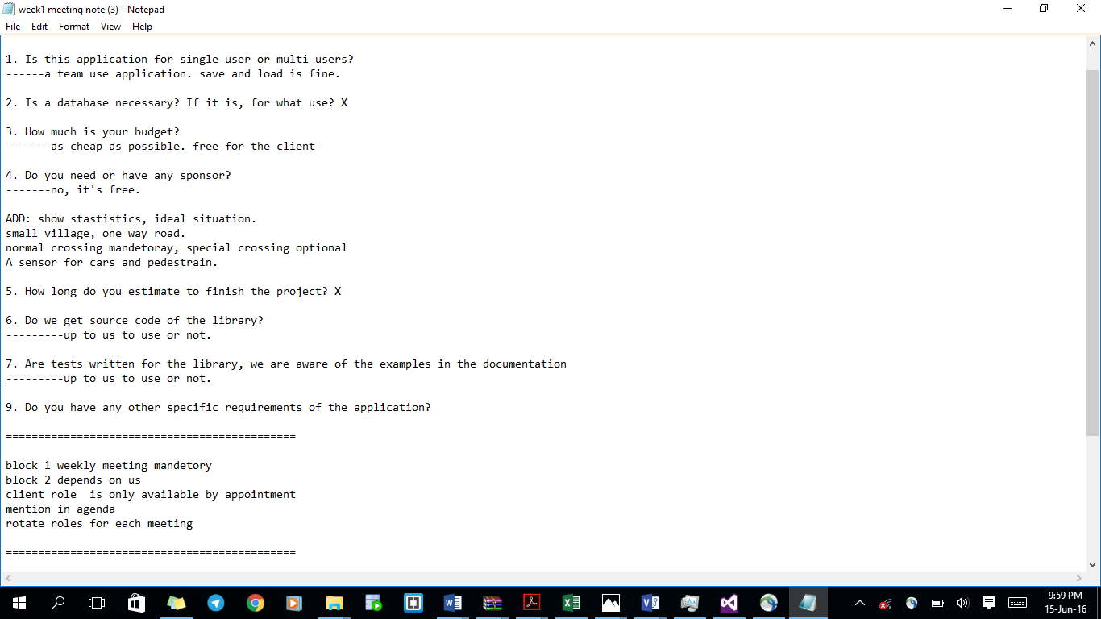**WEEK 1:**   
This was a short meeting, the forming stage of the group. Where the group members interacted with each other to get to know each other more and also know where each of our areas of expertise lies.   
We had our first deadline to hand in the first version of the Project Plan, so we then began to work on the version 1 of the Project Plan and submitted it before the given deadline. We also prepared for our first meeting with the teacher/client the next week.

**WEEK 2:**   
As we scheduled with the teacher, we had a meeting to receive feedback on the first version of the project plan. There was some feedback received which is shown in the image. We also improved our document according to the feedback and worked on the first version of the requirements.

In addition to this, we also got some feedback on the project plan which includes fixing the risk section, not necessary on the money part, etc.

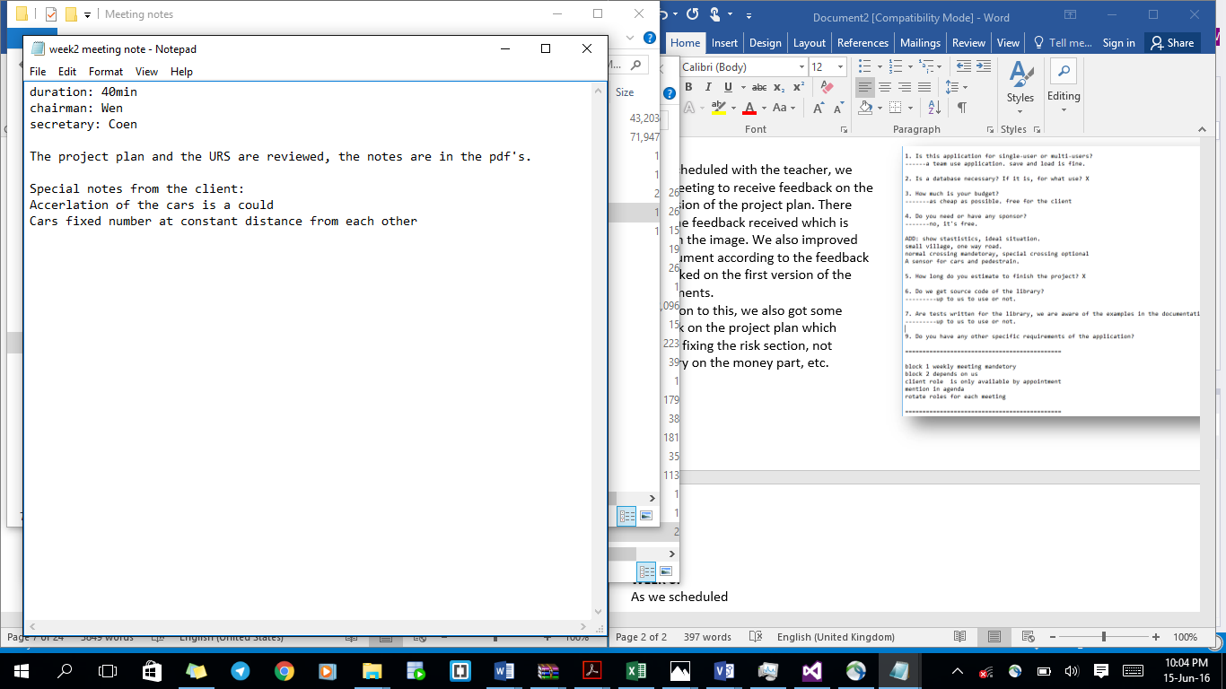**WEEK 3:**   
This week was to discuss the project plan and URS document in order to identify changes in order to modify the final version. Most of the feedback was used to improve the document. The client also requested for a report showing some statistics of the simulation. But we as a group decided that due to time constraint, this will be a should when implementing the project.

**WEEK 4:**   
The meeting this week was to get a review on our documents and information about the grade of the project plan and requirements document. We also worked on the first version of the test document, to be handed in by the end of the week.

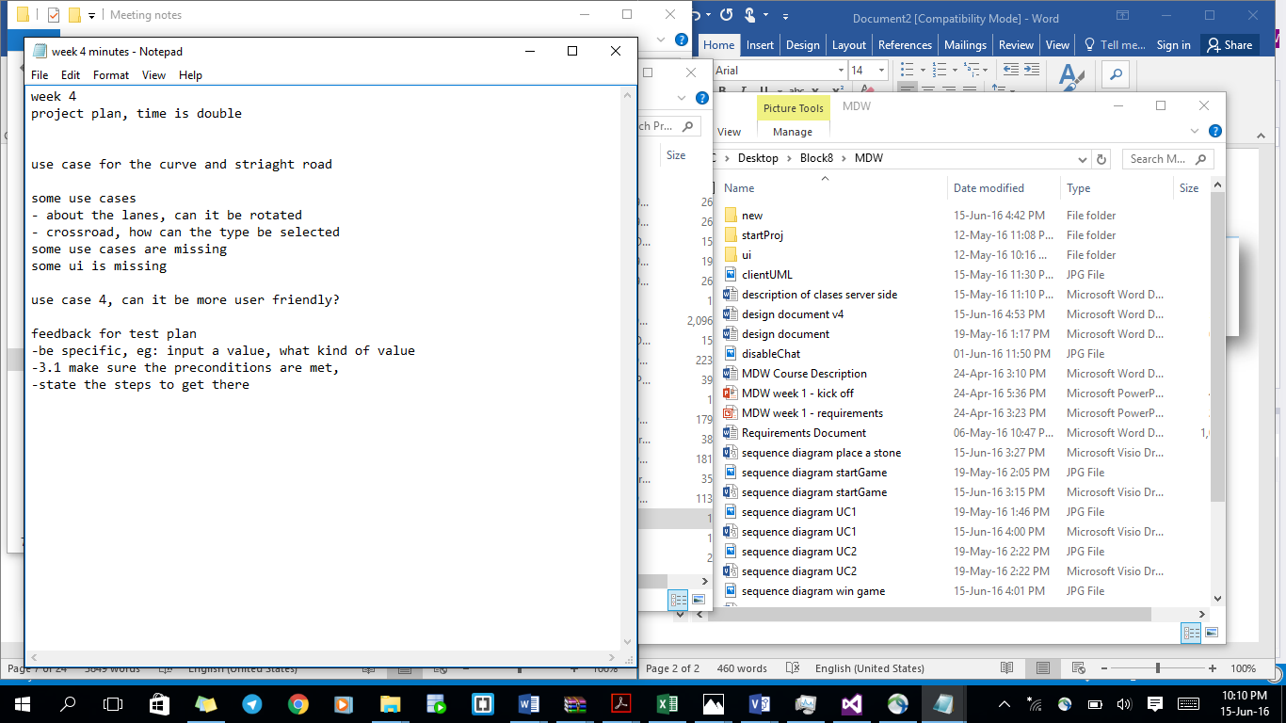

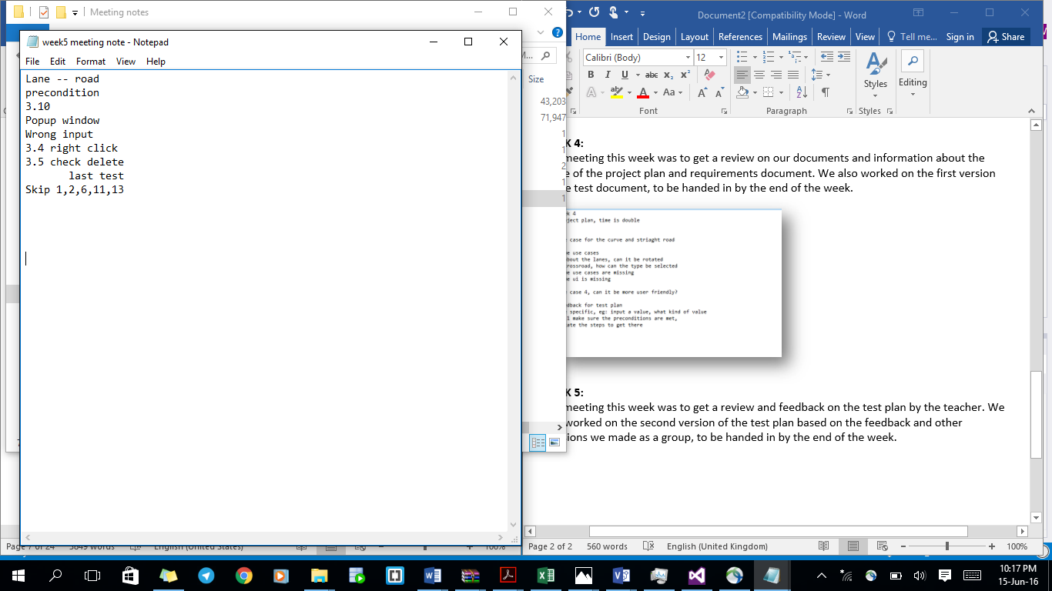**WEEK 5:**   
The meeting this week was to get a review and feedback on the test plan by the teacher. We also worked on the second version of the test plan based on the feedback and other decisions we made as a group, to be handed in by the end of the week. The image just shows a few minutes on the feedback received.

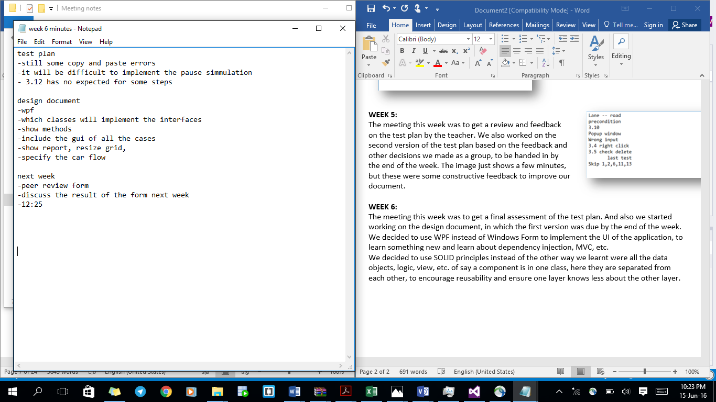**WEEK 6:**   
The meeting this week was to get a final assessment of the test plan. And also we started working on the design document, in which the first version was due by the end of the week.

We decided to use WPF instead of Windows Form to implement the UI of the application, to learn something new and learn about dependency injection, MVC, etc.

We decided to use SOLID principles instead of the other way we learnt were all the data objects, logic, view, etc. of say a component is in one class, here they are separated from each other, to encourage reusability and ensure one layer knows less about the other layer.

# Task Delegation

|  |  |  |  |  |
| --- | --- | --- | --- | --- |
| **Work Type** | **Deliverable Area** | **ID** | **Description** | **Owner** |
| Programming | Common layer | 1 | Common layer coding | Agnes |
| Review | Common layer | 1 | Common layer review | Coen |
| Review | Common layer | 1 | Common layer review | Agnes |
| Programming | Data layer | 2 | Data layer coding | Wen |
| Programming | Data layer | 2 | Data layer unit test | Wen |
| Review | Data layer | 2 | Data layer review | Coen |
| Review | Data layer | 2 | Data layer review | Wen |
| Programming | Launcher layer | 3 | Launcher layer coding | Yongshi |
| Review | Launcher layer | 3 | Launcher layer review | Coen |
| Review | Launcher layer | 3 | Launcher layer review | Yongshi |
| Programming | Bussiness layer | 4 | Gridmodel coding | Wen |
| Programming | Bussiness layer | 4 | Gridmodel coding | Yongshi |
| Testing | Bussiness layer | 4 | Gridmodel unit test | Wen |
| Testing | Bussiness layer | 4 | Gridmodel unit test | Yongshi |
| Review | Bussiness layer | 4 | Gridmodel review | Coen |
| Review | Bussiness layer | 4 | Gridmodel review | Wen |
| Review | Bussiness layer | 4 | Gridmodel review | Yongshi |
| Programming | Bussiness layer | 5 | Simulator timer | Agnes |
| Programming | Bussiness layer | 6 | Simulator traffic light | Agnes |
| Programming | Bussiness layer | 6 | Simulator traffic light | Wen |
| Testing | Bussiness layer | 6 | Simulator traffic light unit test | Agnes |
| Testing | Bussiness layer | 6 | Simulator traffic light unit test | Wen |
| Review | Bussiness layer | 6 | Simulator traffic light review | Coen |
| Review | Bussiness layer | 6 | Simulator traffic light review | Agnes |
| Review | Bussiness layer | 6 | Simulator traffic light review | Wen |
| Programming | Bussiness layer | 7 | Simulator car | Yongshi |
| Testing | Bussiness layer | 7 | Simulator car unit test | Yongshi |
| Review | Bussiness layer | 7 | Simulator car review | Coen |
| Review | Bussiness layer | 7 | Simulator car review | Yongshi |
| Programming | Bussiness layer | 8 | Simulation pedestrian | Unassigned |
| Testing | Bussiness layer | 8 | Simulation pedestrian unit test | Unassigned |
| Review | Bussiness layer | 8 | Simulation pedestrian review | Coen |
| Review | Bussiness layer | 8 | Simulation pedestrian review | Unassigned |
| Prestudy | Presentation layer | 9 | Prestudy WPF + MVVM | Wen |
| Prestudy | Presentation layer | 9 | Prestudy WPF + MVVM | Yongshi |
| Prestudy | Presentation layer | 9 | Prestudy WPF + MVVM | Agnes |
| Programming | Presentation layer | 10 | Designing UI | Yongshi |
| Programming | Presentation layer | 11 | ViewModels in C# | Wen |
| Programming | Presentation layer | 12 | ViewModels in View | Wen |
| Review | Presentation layer | 13 | ViewModels in View review | Coen |
| Review | Presentation layer | 13 | ViewModels in View review | Wen |
| Programming | Presentation layer | 14 | UserControls for Components, cars, pedestrians | Agnes |
| Programming | Presentation layer | 14 | UserControls for Components, cars, pedestrians | Wen |
| Programming | Presentation layer | 14 | UserControls for Components, cars, pedestrians | Yongshi |
| Review | Presentation layer | 14 | UserControls for Components, cars, pedestrians review | Agnes |
| Review | Presentation layer | 14 | UserControls for Components, cars, pedestrians review | Coen |
| Review | Presentation layer | 14 | UserControls for Components, cars, pedestrians review | Wen |
| Review | Presentation layer | 14 | UserControls for Components, cars, pedestrians review | Yongshi |
| Programming | Presentation layer | 15 | General MainWindow | Yongshi |
| Programming | Presentation layer | 16 | Resize grid window | Agnes |
| Programming | Presentation layer | 17 | Traffic light window | Wen |
| Programming | Presentation layer | 17 | Traffic light window | Agnes |
| Review | Presentation layer | 18 | Review Presentation layer | Agnes |
| Review | Presentation layer | 18 | Review Presentation layer | Coen |
| Review | Presentation layer | 18 | Review Presentation layer | Wen |
| Review | Presentation layer | 18 | Review Presentation layer | Yongshi |

# Explanation of choices as solutions to problems encountered

**Use of a Library:**   
We came to a realisation that implementing the property changed event for updating data fields when a change has occurred, needed more effort and time to implement.   
We came up with an alternate solution to use a library which automatically fills the getters and setters for the property change.

**Preventing the possible occurrence of a deadlock:**  
There was a problem we encountered, the cars were standing in a deadlock position on the crossroad sometimes. After analysing various possible solutions to this problem, we came to a decision to allow the light to stay orange until all the cars have left the centre of the crossroad and this solution when implemented, solved the deadlock problem of cars in the simulation.

**Check when the car should enter the crossroad:**

We observed that the orange light stays for a long time until all the cars have left the centre of the crossroad.

In order to solve this problem, we made sure cars will only enter the centre of the crossroad when the outgoing lane is free.

**Collision Detection:**  
By testing and observing, we realised that collision detection between cars is slow. And that was because collision detection was done for the whole grid, and this will obviously need a lot of time to process.   
We decided to use multithreading, each component has its own thread. And then we ensure collision detection takes place in each component separately.   
  
**Simulation waits for the UI:**  
Our observation was that the simulation does not wait for the UI to add/remove cars, the cars that have to be added are filled into a queue. And by the use of FirstInFistOut(FIFO), the members of the queue are added to the UI when the thread runs.

**Simulation runs too slow:**  
The problem with the simulation not being time effective was encountered, we decided to implement a solution to this problem by use multithreading, which makes use of Read/Write locks on the list of cars as illustrated earlier in collision detection. The Read locks are use to Add/Remove a car from the list of cars in the simulation. The write lock is responsible for showing the items in the thread to the User Interface.

**Maximum speed of the simulation:**

Being aware of the need to run the simulation in maximum speed depending on the user. We decided to implement that functionality with a while loop instead of a timer for efficiency.

# Personal Evaluations

**Name of Group Member : Yongshi Liang**  
During this project, I learn a lot of new skills than in the previous projects. The main reason is, this time, I am having a good team. Each group member has their strength point. Agnes is good at documentation, that is teaching me how to write document in a good format in the future. Coen is good at programming skills, he taught us some nice patterns which we have not learned yet from the previous courses. That we can use it later when we are having an internship. Wen is good at Explanation. When I was messing up or have something does not understand, she would use examples to make me much easier to catch that point. I think the project itself does not difficult, but we are making it more challenging cause we using lots new patterns that we did not know before. We are working hard to understand how to implement it. Discussing it together, spending more time on learning new stuff. After that, I really learned a lot, improved and refreshed my skills. The success of it is thanks to the great teamwork we have.

**Name of Group Member : Wen Li**We did something pretty different than what we did in ProP. This course is supposed to let us utilize what we learnt from the two years to a reality related project. However, for me it does not feel like a project but somehow some kind of teaching and learning course. This is because we chose to use a method that most of us were not familiar with. It took extra time and effort. The process was challenging and we after all learnt a lot of new skills and knowledge. The team cooperates well and the teacher is helpful.

**Name of Group Member: Coen Stange**  
For me PROCP was tougher than I expected, I guess made it more difficult than it supposed to be myself. I wanted to teach my teammates some sick programming skillz, stuff that they can learn know and use later when they have internship/job. Teaching some patterns was more difficult than I expected, but I hope it will be worth it. In this process I guess I got myself more teaching experience, and learn how to be more patient.

**Name of Group Member: Agnes Wadee**  
This project in my opinion was difficult and time consuming, but however, we worked very well as a team to embrace the challenge and ended up with a successful project. I had no knowledge of WPF, but through this project I learnt a lot, and also Coen was really patient in teaching us and reviewing our code in the project. As most projects, not only did I gain experience in software development, but I also learn to improve my team working skills. I had a really good group to work with, everyone is hardworking and strives for the best.   
If there was something that needs to be changed about this project, I will suggest to adapt Agile SCRUM methodology instead of Waterfall, even though waterfall could be helpful for large projects, I highly doubt that you will able to plan exactly how your software will work upfront. I think it is good to have a good draft at the start and then work with it and constantly improve it.